Opportunities for development of tourism of Siberian region and neighboring areas

On behalf of the National research Tomsk state university and Tomsk regional branch of Russian Geographic society auspiced by the Department of culture and tourism of Tomsk region and the Department of general education of Tomsk region are delighted to host the 19th theoretical and practical conference with international participation taking place October 27–28, 2022

Opportunities for development of tourism of Siberian region and neighboring areas

Proposed topic areas

- Regional tourism and hospitality sphere as the factor of economic areas development;
- Regional aspects of sustainable tourism development: problems and tendencies;
- Problems and prospects of using tourist and recreation potential of Siberian region;
- Geographical factors as the conditions of tourism development;
- Ancient "Lukomorye" in regional aspects of tourism development;
- Development of noncommercial types of tourism (social, child's, amateur);
- Museum and exhibition business in regional tourism development;
- Manpower training for tourism and hospitality sphere.

Types of conference sessions

• presentation at the plenary session
• presentation at the workshop
• publication without attending the conference
• online participation

Conference languages: Russian, English

We are delighted to welcome to this event

Research and educational institution staff members, public authorities and local government representatives, tourist enterprises, self-regulating tourist firm workers, students and other interested people.
The collection of the conference publications is to be published by the beginning of the conference. An ISBN is assigned to the journal.

The papers will be accepted till September 30, 2022. The papers are to be sent by e-mail: tourism2013@vtomske.ru or by registered letters to the following address:

The Department of local history and tourism,
pr. Lenina 36, TSU, GGF,
Tomsk, Russia
634050.
Or
Room 205,
ul. Arkadia Ivanova 49,
Tomsk, Russia
634050
Phone.: +7 (3822) 420 800
e-mail: tourism2013@vtomske.ru
website: http://ggf.tsu.ru/content/faculty/structure/chair/tourism/conference/

Contact person: Smolyarchuk Irina N.

The registration fee for full-time participation is 1200 rubles for an article of three pages or less. The volume of the article can be increased to seven pages with an additional payment of 150 rubles per page of text. For remote and correspondence participation, the registration fee is 1000 rubles.

The contribution can be paid in organizing committee during the registration.
From students and schoolchildren, materials for publication up to 3 pages are paid in the amount of 250 rubles. The volume of the article can be increased to seven pages with a payment of 100 rubles. for an extra page of text. In the article, it is obligatory to indicate the supervisor of the work, his place of work and position on the next line after the author of the article.
The supervisor can be a co-author of an article in the student section, paying for the publication in the amount of 1000 rubles for a 3-page article.

The publication can be paid for by transfer to the card of Sberbank of Russia No. 2202 2002 8817 2651 (Irina Nikolaevna S., Ирина Николаевна С.). Send a copy of the payment receipt or a screenshot of the payment confirmation screen to the email address of the Organizing Committee.

All participants have an opportunity to present their tourist and excursion programmes during the conference; in this case you should inform the organizing committee beforehand.
For booking a hotel room you should apply to the organizing committee of the conference.

Call for papers: the papers should be presented in Microsoft Office Word. Sheet size – A4 margined 2 cm from every quarter. The title must be printed in upper-case letters in bold type, Times New Roman, 12-point type aligned to the center. The author’s family name and initials are printed lower in one line spacing with lower-case letters, in italics, 12-point type, and the full name of organization and the city separated by commas. The abstract (3-5 lines) and key words (3-5) are printed in one line spacing.
The text is to be printed lower in one line spacing in single spacing with indentation of 1 cm, justified alignment, 12-point type without hyphenation. After the text in one line spacing the ‘works cited’ or ‘bibliography’ is printed in bold type aligned to the center, 12-point type. It is printed in alphabetical order or in order of reference in the paper, 12-point type (see the sample below).
Graphics should be drawn in black-and-white shot (the collection will be made in grey gradation), pictures should be put in the text. The pictures names and numbers are coming under the pictures, and the tables – above the tables. The references to the works should be in square brackets, and to the pictures and tables – in parentheses.
The paper content should be not less 3 and not more 7 pages (including works cited, tables and pictures).
The application form for the conference participation is to be sent by a separate file in Microsoft Office Word: Ivanov-application form.doc. The paper text is to be sent in another file titled Ivanov-paper.doc. When the materials are received, the organizing committee will send you the notification. Those, who have sent the materials but have not received the notification, should duplicate the sending.
The organizing committee reserves the right to decline the materials which are inadequate or not corresponded to the conference topics.

Sample of paper organization:

THE SIGNIFICANCE OF SEASON APPROACH BY ESTIMATION OF TERRITORY RECREATIONAL POTENTIAL

Filandysheva L.B., Soroka A.S., Kisler V.V., Tomsk state university, Tomsk

Abstract abstract abstract abstract abstract abstract abstract abstract abstract abstract abstract abstract abstract abstract abstract abstract abstract abstract abstract abstract abstract abstract abstract abstract abstract abstract abstract abstract abstract abstract abstract abstract abstract abstract abstract abstract.

Key words: word, word, word, word, word

Studying the recreational potential of a territory, the climate conditions should be considered in the context of their natural seasonal rhythm, because most sorts of recreation, tourism and medical treatments demand specific climatic conditions and certain state of land and water [1].

Works cited
- Danilova N.A. Climate and recreation in our country – Moscow.: «Mysl», 1980. – 154 p.
- Informational project on tourism [Electronic resource]. – URL:// http://www.kukiani.ru/index.php?page=content&subpage=s&r=9&p=28&s=103
- Mitin I.I. Tourist myths and complex characteristics of the territory in humanitarian geography // Tourism and cultural heritage: collection of researches. Issue 3. – Saratov: Nauchnaja kniga, 2006.
- Theoretical foundations of recreational geography / ed. V.S. Preobrazhensky. –М.: Nauka, 1975. - 224 p.
Sample of drawing organization:

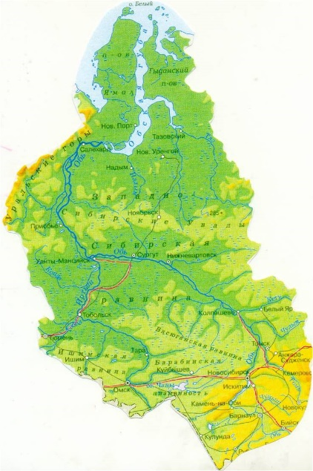

Drawing 1 – Physiographic map of Western Siberia [1]

Sample of table organization:

Table 2 – Средние месячные температуры воздуха на ст. Салехард за периоды с 1936 по 1970 гг., с 1971 по 2000 гг., с 2001 по 2012 гг. и разница между ними.

Периоды | Месяца*
 | Октябрь | Ноябрь | Декабрь | Январь | Февраль | Март | Апрель | Май | Июнь | Июль | Август | Сентябрь
1936-1970  (первый) | -3,7 | -14,5 | -20,8 | -23,2 | -23,0 | -18,2 | -8,3 | -1,0 | + 8,4 | +14,3 | +11,6 | +5,4
1971-2000  (второй) | -3,6 | -15,6 | -20,9 | -23,7 | -22,4 | -14,5 | -9,2 | -0,6 | +9,1 | +14,5 | +11,1 | +5,3
Разница между периодами | +0,1 | -1,1 | -0,1 | -0,5 | +0,6 | +3,7 | -1,1 | +0,4 | +0,7 | +0,2 | -0,5 | -0,1
1936-1970  (первый) | -3,7 | -14,5 | -20,8 | -23,2 | -23,0 | -18,2 | -8,3 | -1,0 | + 8,4 | +14,3 | +11,6 | +5,4
2001-2012  (третий) | -1,8 | -14,3 | -19,6 | -22,6 | -23,7 | -16,1 | -8,3 | +0,2 | +10,5 | +14,8 | +11,4 | +5,9

Application form
for participation
in 19th theoretical and practical conference

Opportunities for development of tourism of Siberian region and neighboring areas
Tomsk, Russia

1. Full name:
2. Place of employment (study)
Name of the organization
Name of the department (faculty, major):
3. Position:
Academic degree:
Academic title:
Year of the course (for students):
4. Phone number:
Fax:
5. Address for delivery (with code):
6. E-mail:
7. Type of the conference session:
presentation only publication
8. Presentation topic:
9. Accommodation
For booking a hotel room you should apply to the organizing committee beforehand

Date:

