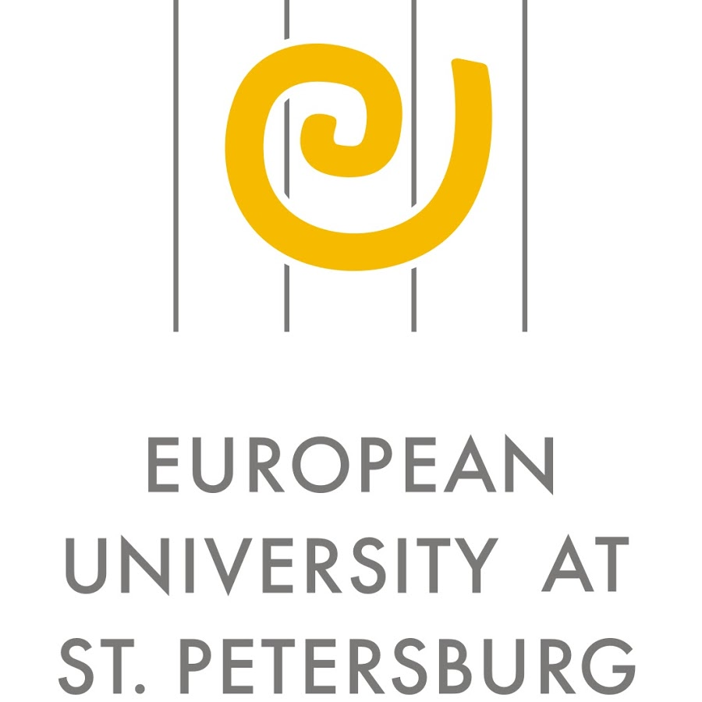
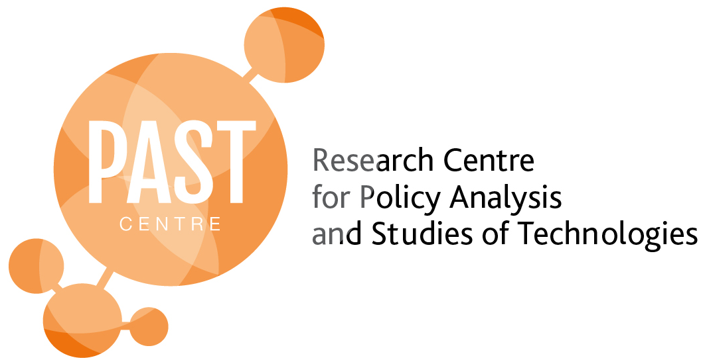

III Conference

Social Sciences & Health Innovations:
Making Health Public

PROGRAMME

22-24 May 2017,
National Research Tomsk State University, Tomsk, Russia

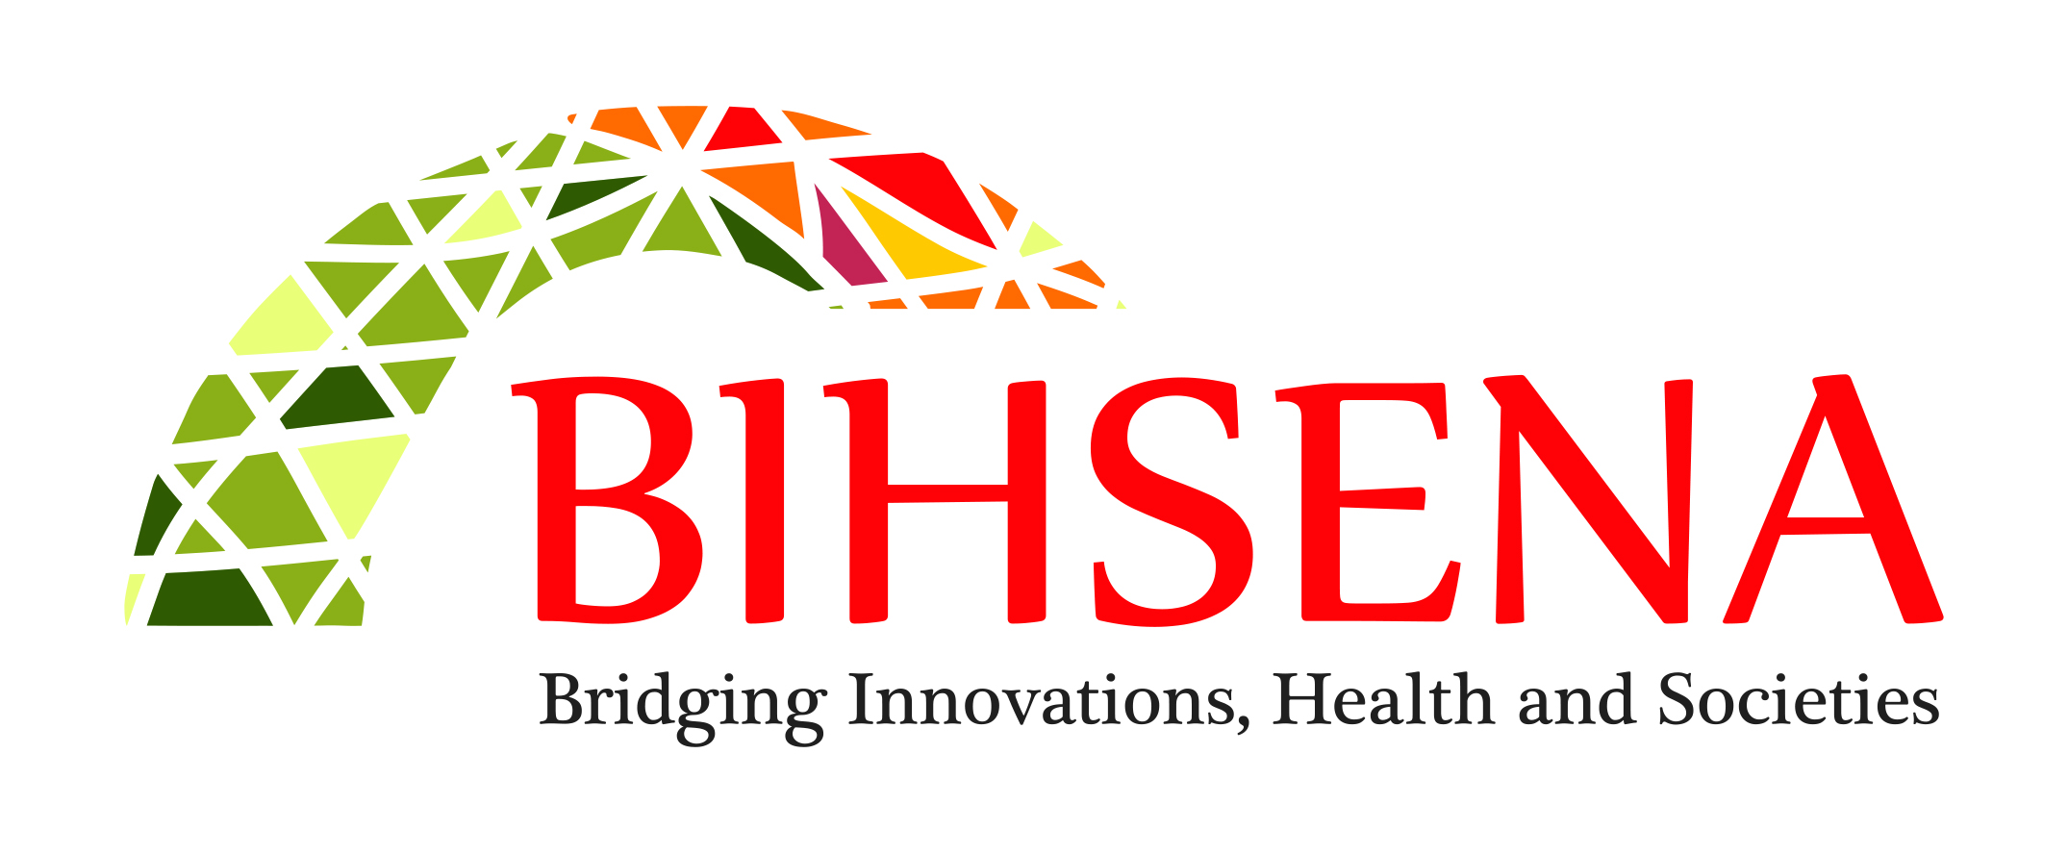

Conference Committee:

Olga Zvonareva, Research Fellow, Maastricht University/ Policy Analysis and Studies of Technologies (PAST-Centre), National Research Tomsk State University/Siberian State Medical University
Olga Ustyuzhantseva, Research Fellow, Policy Analysis and Studies of Technologies (PAST-Centre), National Research Tomsk State University
Ekaterina Borozdina, Research Fellow, European University at Saint-Petersburg
Maria Shevchenko, Head of International Collaboration Department, Siberian State Medical University

Advisory Board:

Klasien Horstman, Professor of Philosophy of Public Health, Maastricht University
Evgeniya Popova, Director of Research Centre for Policy Analysis and Studies of Technologies (PAST-Centre), National Research Tomsk State University
Susanne Bauer, Associate Professor at the Centre for Technology, Innovation and Culture, University of Oslo
Jessica Mesman, Associate Professor at the Department of Technology and Society Studies, Maastricht University

Support group:

Headed by Lyubov Torlopova, Junior Researcher, Policy Analysis and Studies of Technologies (PAST-Centre), National Research Tomsk State University

Conference venue:
Conference hall, Scientific Library, National Research Tomsk State University (TSU), prospect Lenina 34, old building, 2nd floor
Small hall, Scientific Library, TSU, prospect Lenina 34, old building, 1st floor
Hall #209, Main Building, TSU, prospect Lenina 26, 2nd floor
Hall #7, Scientific Library, TSU, prospect Lenina 34, new building, 2nd floor
German literature hall, Scientific Library, TSU, prospect Lenina 34, 3rd floor

TSU Scientific library, old building
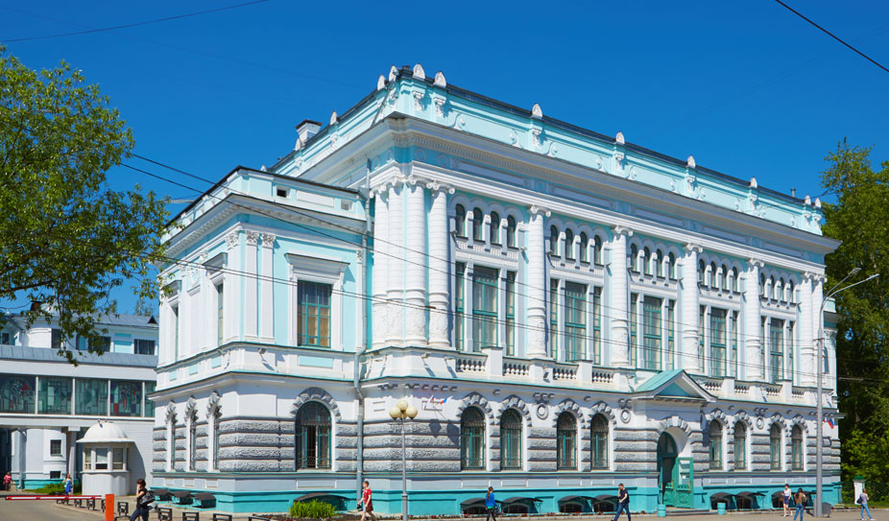

TSU Scientific library, new building
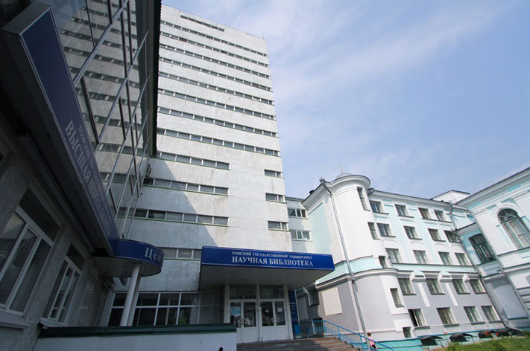

TSU, main building
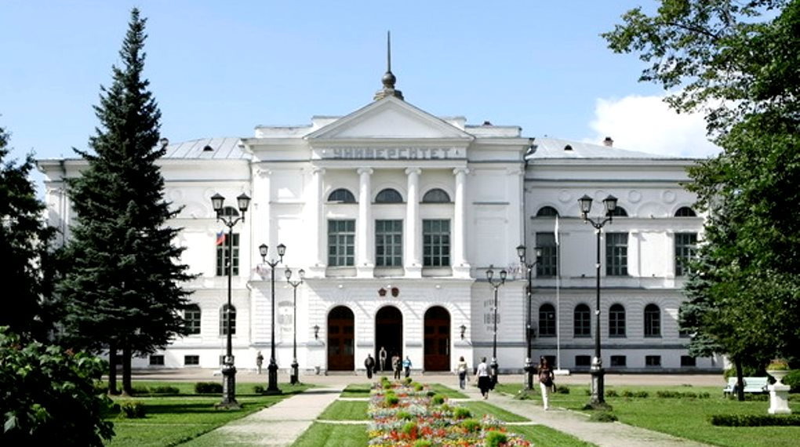

 | May 22nd |  | May 23rd |  | May 24th
9.00 |  |  | 3. Defining health – framing experiences?  Small hall, Scientific Library TSU | 4. Towards public mental health: innovations for children and youth  Hall #7, Scientific Library TSU | 7. Psychological determinants of health from local communities to global healthcare  Hall #7, Scientific Library TSU | 8. Engaging technology in public health: promises and ambivalences  Small hall, Scientific Library TSU
9:30
10:00
10:30
11:00 | Participant registration  Conference hall, Scientific Library TSU
11:30 | Conference opening. Welcome |  | Coffee break |  | Coffee break | Round table 3. Fighting antimicrobial resistance together  Small hall, Scientific Library TSU
12:00 | Key-note Lecture 1. Statistics need stories. The urgency of media approaches in public health  Martine Bouman  Conference hall, Scientific Library TSU |  | Key-note lecture 2. ‘Valuing health’  Tiago Moreira  Conference hall, Scientific Library TSU
12:30
13:00
13:30 | Lunch break |  | Lunch break |  | Lunch break
14:00
14:30 | 1. The diverse knowledges in public health: controversies and contestations  Small hall, Scientific Library TSU | 2. Bridging perspectives on care  Hall #209, Main Building TSU | 5. Building responsive institutions  Small hall, Scientific Library TSU | 6. The transformation of childbirth  Hall #7, Scientific Library TSU | 9. Medical practices: experiences of health professionals and patients  German literature hall, Scientific Library, TSU | 10. Attuning public health measures to local needs and practices  Small hall, Scientific Library TSU
15:00
15:30
16:00
16:30
17:00 | Coffee break |  | Coffee break |  | Key-note lecture 3. Making health cosmopolitical  Conference hall, Scientific Library TSU
17:30 | Round table 1 ‘Transforming education: training now health professionals of the future’  Small hall, Scientific Library TSU |  | Round table 2: Innovative development of the Russian medical industry: taking stock  Small hall, Scientific Library TSU
18:00
18:30 |  |  |  |  | Banquet  Scientific Library TSU
19:00
19:30
20:00

Conference theme
The conference aims to explore how health is, and can be, made public. What exactly does the ‘public’ stand for in public health? Public refers to collectives and solidarities on a local, national and global scale; but how are they made, maintained and legitimized amidst diversity of the globalizing world? Public also refers to the responsibilities of public institutions for health, and engagement of these institutions with people’s concerns. However, during the last decades it has become clear that there are often big gaps between institutional perspectives and the perspectives of communities and citizens on health and ways to improve it. International debates about HIV prevention have been an eye-opener in this respect. Many public health bodies tend to work in a top down manner and do not attune well to local practices, needs and perspectives. One often wonders, where the publics of public health are. Does the development of evidence-based public policies improve the quality of public health programs, or does it increase the gap with everyday practices? What counts as relevant evidence? Which kinds of knowledge shape public health programmes and how is this knowledge developed? The rise of big data poses the question of how to relate statistical risk technologies to narratives and everyday life notions of risk, illness, responsibility, and a good life. Is it necessary to make public health more participatory and more ‘public’ to make it more effective, and if so, how to do that? Which roles do innovations, whether, conceptual, technical or social, play in this regard and how can they contribute into ‘making health public’? How do media construct health as a public issue, and how can media – through encouraging literacy, storytelling, and entertainment – contribute to empowering publics?

Social sciences play a central role in analysing public health innovations’ dynamics and for understanding the corresponding challenges. This conference examines the complexities of making health public by engaging the perspectives of the social sciences, including science and technology studies (STS), medical anthropology, sociology and history. Furthermore, it is meant to serve as a platform to facilitate dialogue between social and biomedical scientists, public health professionals and policy makers, and for engagement between scholars and practitioners working in the field of health innovations in the post-Soviet region and globally. The conference considers public health-related innovations on different levels (from the community level to national programmes and global efforts) and of different kinds (conceptual, organisational, political).

May 22nd, 2017 (Monday)

11:00-11:30 – Participant registration
11:30-12:00 – Conference Opening. Welcome

12:00-13:30 – Keynote lecture Statistics need stories. The urgency of media approaches in public health.
Location: Conference hall, Scientific Library TSU

Martine Bouman (Centre for Media & Health and Erasmus University Rotterdam, The Netherlands)
Discussant: Maria Shevchenko (Siberian State Medical University, Russia).
The media’s role in setting the health agenda has grown substantially over the past few decades. Health issues are not considered relevant unless they are made visible. Information about health issues has to compete with thousands of other communication messages. The attention of target audiences is to be caught and held, especially when that audience is not yet interested in health issues. It is no longer sufficient to rely solely on the rationality of health message. Other, more emotionally appealing and popular communication methods also have to be brought into play. Using storytelling can make health issues more accessible. Integrating health issues in popular media formats (in theater, film, music, television, new media, or experience parks) is known as the entertainment-education (EE) strategy. The idea of ‘entertainment with an added value’ poses a big challenge for science, policy and practice. With a rapidly changing media landscape the distinction between media creators and audiences is becoming increasingly diffuse. Social media (e.g., Facebook, WhatsApp, Twitter, Skype, YouTube, MySpace, Pinterest, Instagram, blogs) have become an integral part of our daily lives. This creates a unique opportunity to make public health more participatory and more public. This also contributes to the emergence of new classes of online professional creatives, serious game designers, social influences and community owners. Which roles do these media innovations play and how can they contribute into 'making health public'? How can media - through encouraging storytelling, and entertainment - contribute to empowering publics? Martine Bouman will share her experience and research on the entertainment education strategy and on creating a crossover between public health and the creative media industry. She will illustrate this with examples and film fragments.

13:30-14:30 – Lunch break

1. The diverse knowledges in public health: controversies and contestations

Location: Small hall, Scientific Library TSU
The section focuses on the multiplicity of kinds of knowledge at work in public health and what happens when they clash. How is credibility of knowledge negotiated? Whose expertise is to guide decision-making with regards to people’s health? Special attention is given to the voices of various publics and their roles in redefining established approaches to health, treatments, and public health risks.
The section begins with the plenary talk by Floor Moes on evidence-based policymaking in a ‘post-truth’ era. There is something the matter with ‘facts’. In contemporary knowledge societies, scientific knowledge has become an integral element of politics and governance of healthcare. At the same time, the authority of scientific advice is being challenged more frequently in the public domain. On the one hand, we have witnessed the rise of a ‘new regime of truth’ (Lambert 2006), that of empirically based quantitative evidence. We produce more data and metrics than ever before (Adams 2016). On the other hand, we live in a world in which ‘facts’ are easily overturned. The Oxford Dictionary made ‘post-truth’ its ‘word of the year 2016’. As knowledge has come to play a more central part in health care governance, the question of whose knowledge counts for such decisions has become politically and morally charged. Some scholars have found that the processes of scientification of public policy actually go together with processes of politicisation of scientific knowledge (Hoppe 1999; Weingart, 1999). These are delicate issues for experts, scientists and knowledge institutions whose authority, legitimacy and raison d’être lay, originally, in their acknowledged expertise as a basis for policy advice. They have to come to terms with the fact that there is no ‘technocratic fix’ to complex health policy problems (Syrett 2003) and new forms of legitimation are called for. BMJ addressed the ‘post-truth’ issue in their Christmas 2016 edition, writing that we all know that ‘facts can be close to useless if you don’t engage with context and lived experiences’ and so ‘we should respect the space for contrary experiences and work out how facts and evidence interact with them’. There is a deeper philosophical as well as empirical issue that lies before us today: what actually counts as evidence or ‘fact’? Who decides that? How do we weigh different forms of knowledge – e.g. evidence, expertise, experience- against one another in policymaking or medical decisions? In this plenary lecture Floor will explore these questions by looking at her own ethnographic research into the knowledge work of the National Health Care Institute, a central governing body in Dutch health care.

Section chair: Floor Moes (Maastricht University, The Netherlands)
14:30-15:00 Floor Moes (Maastricht University, The Netherlands) Evidence-based policymaking in a ‘post-truth’ era
15:00 – 15:20 Márcio da Cunha Vilar (University of Leipzig, Germany) Autoimmunity, innovation and regulation in Brazil: The synthetic phosphoethanolamine’s case
15:20 – 15:40 Don Eliseo Lucero-Prisno III (Xi'an Jiaotong-Liverpool University, China) A Feast for Crows: Discourses from the Philippines’ Dengue Vaccine
15:40 – 16:00 Elena Sokolova (Institute for Ethnography and Anthropology of the Russian Academy of Sciences, Russia) Human enhancement: activists’ network in Russia
16:00 – 16:20 Sergey Shevchenko (Institute of Philosophy, Russian Academy of Sciences; Pirogov Russian National Research Medical University, Russia) «Distributed knowledge» in medical biotechnologies
16:20 – 16:40 Hernâni Zão Oliveira (University of Porto, Portugal) Media and Glyphosate: between scientific evidence and political (in)decision
16:40 – 17:00 Elena Grebenshchikova (Institute of Scientific Information for Social Sciences of the Russian Academy of Sciences, Russia) Social perception of risks of human enhancement technologies

2. Bridging perspectives on care

Location: Hall #209, Main Building TSU

Understandings and experiences of (health) care diverge widely among those involved, including healthcare professionals, patients, and carers. This section explores these divergences and reflects on how to deal with them. How to make care responsive to needs and preferences of various publics? How to approach conflicts when they arise? What is and can be the role of patients, carers, and their communities in governing (health) care and systems?

The section starts with the plenary talk by Donka Dimitrova on healthcare quality. In professionally dominated health systems health status is associated with provider performance and quality of health care. However health has different meanings accounting for underlying gaps in the perspectives of different stakeholders turning quality of services into an elusive concept. While providers tend to operationally define quality in terms of standards of structure, practice and outcomes, patients value the responsiveness to their needs. Even though the role of the health care consumer receives increased attention, it is often reduced to institutional attempts of shaping expectations through incorporating patient satisfaction in outcome quality indicators. Since health outcomes are experienced by individuals and communities they should be measured at the level of the patients and their families. To effectively inform quality improvement such measures need to consider values, preferences and priorities and attempt systematic monitoring of health needs, behaviors and experiences of target groups. Bridging the gap in perspectives however poses the challenge of expanding the competence and skills of health professionals and communicating various expert views to the public.

Section chair: Donka Dimitrova (Medical University – Plovdiv, Bulgaria)
14:30-15:00 – Donka Dimitrova (Medical University – Plovdiv, Bulgaria) Is healthcare quality in the eyes of the beholder?
15:00 – 15:25 Tetiana Stepurko, Valentyna Anufriyeva (National University of ‘Kyiv-Mohyla Academy, Ukraine), Viktoriya Tymoshevska (International Renaissance Foundation) Quality of out-patient services in Ukraine: users’ perspective
15:25 – 15:50 Alexandra Endaltseva (L'École des hautes études en sciences sociales (EHESS), France/ Linköping University, Sweden) Hacking into the ‘matter of care’: On commitments, creative assemblages, and expertise in Russian Multiple Sclerosis Society
15:50 – 16:15 Denis Tyufilin (Siberian State Medical University, Russia) You can't please everyone or the patient is always right?
16:15 – 16:40 Nikolay Tabakaev (Siberian State Medical University, Russia) Healthcare quality: patient vs. physician
16:40 – 17:05 Barbara Regeer (Vrije Universiteit, Amsterdam, The Netherlands) Reflexive monitoring and evaluation in action: Transdisciplinary m&e for health transitions

17:05-17:30 – Coffee Break.

17:30-19:00 – Round Table. ‘Transforming education: training now health professionals of the future’

Location: Small hall, Scientific Library TSU
Our societies currently face new, ‘wicked’, problems. Addressing these problems would require the new kinds of professionals. Such professionals would possess competencies from a range of diverse disciplines and would be able to span the boundaries between sectors and spheres of life. However, education often lags behind ongoing changes in technologies, the job market, and our understanding of societal dynamics. Health is one of the most important spheres that currently pose a challenge for education systems. Health, as well as illness, constitutes a subject of concern for a number of academic disciplines, including both natural and social sciences. Currently, there is an ongoing quest to develop a comprehensive interdisciplinary view on health and illness and the ways through which ‘good health’ is co-produced by different actors. Such a view draws from both the more traditional health-related fields such as epidemiology and clinical medicine, and also relies on insights from public health, sociology, anthropology, and political economy. A narrow gaze of each discipline can illuminate certain health problems and potential solutions; but only when they are taken together within a fully integrated approach can we properly build an understanding of health and the possibilities for solving health problems. What does this mean for higher education and the training of professionals able to act in situations of rapid sociotechnical change, new health risks, and limits of health systems’ resources? Focusing on the domain of health, participants of this round table will discuss the future of education and universities.

- What is health and how to improve it in contemporary societies? What do our evolving interdisciplinary understandings of health mean for education?
- What kinds of health professionals are to be trained today; taking account of societal needs, public health problems, and ongoing technoscientific developments?
- Which competencies should health professionals of the future possess and how to introduce these competencies in the curricula?
- Do education systems need a new kind of teacher and which competencies and skills would such a teacher need?
- How should we conceive the relationships between universities and society?

Moderators: Valentyna Anufriyeva (National University of ‘Kyiv-Mohyla Academy, Ukraine) and Denis Tyufilin (Siberian State Medical University, Russia)

Speakers:

Olga Kalachikova (National Research Tomsk State University, Russia) Contemporary education: contexts and subjects of change

Yulia Kovshirina (Siberian State Medical University, Russia) Modernization of medical education in Russia

Elena Syurina (Vrije Universiteit Amsterdam/Maastricht University, The Netherlands) Learning from each other: new education methods for mixed background classroom in health

Donka Dimitrova (Medical University – Plovdiv, Bulgaria) Systems thinking as core competence in healthcare

Junona Gorelova (Siberian State Medical University, Russia) Creation and functioning of multidisciplinary medical teams

Valentina Kharitonova (Institute of Ethnology and Anthropology, Russian Academy of Sciences, Russia) Medical anthropologists in Russia: education, scientific specialization, professional practices

May 23rd, 2017 (Tuesday)

3. Defining health – framing experiences

Location: Small hall, Scientific Library TSU

This section interrogates definitions of health produced by different metrics, expert bodies, and societal orders. How various approaches to defining good and poor health feed into and shape experiences of individuals and collectives? Who has the power to produce definitions and what the implications are for including and excluding certain perspectives?
The section starts with the plenary talk by Susanne Bauer who takes up some recent STS debates on publics in order to reflect on how public health is known, researched and acted upon. Experimenting with emerging work at the intersection of STS and health sciences, Susanne Bauer explores different reflections, critiques and ways of knowing and doing public health. What can we learn from researching problematizations, infrastructures, issue formation and material semiotic relations when it comes to ways of knowing and acting in public health? What are the potentials of these different approaches for interventions in the calculative infrastructures shaped by risk factor epidemiology, its metrics, orderings and policies directed to mass health? She will attempt to combine an STS reflection on measures and metrics with a reflection on publics of and beyond in public health.

Section chair: Susanne Bauer (University of Oslo, Norway)
9:00-9:30 – Susanne Bauer (University of Oslo, Norway) The Politics of Metrics and Measures. From Population Health to Health Publics
9:30 – 9:55 Torlopova Lyubov (Tomsk State University, Russia) The Production of Disability in Russian Sociomedical Expertise Bureau
9:55 – 10:20 Anastasia E. Zaitseva (Tomsk State University, Russia) Social aspects of rehabilitation of children with Type 1 diabetes mellitus
10:20 – 10:45 Julia Unzhakova (Tomsk State University, Russia) Quality of life of teenagers with obesity
10:45 – 11:10 Julia Zelikova (Higher School of Economics, Russia) Social Capital and Health of Older People in Russia
11:10 – 11:35 Pavel Vasilyev (Van Leer Jerusalem Institute, Israel) Managing the Soviet Period: Menstrual Innovations and Bodily Practices

4. Towards public mental health: innovations for children and youth

Location: Hall #7, Scientific Library TSU
There is no public health without mental health because of the connectedness between mental illness and other health conditions. Yet many mental health needs, especially in young people, continue to be unmet. This section investigates how mental health needs of children and youth can be identified and met for them to fulfil their potential and contribute fully to the development of their communities.
The section begins with the plenary talk by Alexander Kornetov on suicidal behavior in adolescence. Every 40 seconds a person dies by suicide somewhere in the world. Over 800 000 people die by suicide every year. Worldwide, suicide is the tenth most common cause of death. It is predicted that by 2020 suicide will be the second most prevalent cause of death surpassing cancer and cardiovascular diseases. However, already today in people between the ages of 15 and 34, suicide has become the third cause of death. This talk provides an overview and the fundamental aspects of suicide and suicide attempts as well as actionable steps for suicide prevention in adolescence. Suicide and suicide attempts will be defined, worldwide statistical data presented and key risk factors discussed, including: health system and societal risk factors, individual risk factors, psychiatric risk factors, and indications of suicide risk. Also attention will be given to interventions with special care given to selective interventions. The situation regarding adolescent suicide in Tomsk will be highlighted.
Section chair: Alexander Kornetov (Siberian State Medical University, Russia)
9:00-9:30 – Alexander Kornetov (Siberian State Medical University, Russia) Suicidal behavior in adolescence: an overview and fundamental aspects
9:30 – 9:55 Emma de Wit (Vrije Universiteit Amsterdam, the Netherlands) Reducing Stress in Youth: A Pilot-Study on the Effects of a University-Based Intervention Program
9:55 – 10:20 Elena Yakunina, Natalia Shaftelskaya (Tomsk State University, Russia) Psychophysiological aspects of communicative collective dance
10:20-10:45 Ekaterina Vdovenko (Tomsk State University, Russia) Types of reactions to frustrations of adolescents with diabetes mellitus
10:45 – 11:10 Natalia Trenkaeva (Tomsk State University, Russia) Рsychological health and safety of university educational system participants
11:10 – 11:35 Elena Syurina (Vrije Universiteit Amsterdam/Maastricht University, The Netherlands) "Stress-out": evaluation of biological measurements of stress in children

11:30-12:00 – Coffee Break.

12:00-13:30 – Keynote lecture Valuing Health
Location: Conference hall, Scientific Library TSU
Tiago Moreira (Durham University, UK, and Copenhagen University, Denmark)
Discussant: Floor Moes (Maastricht University, The Netherlands)

What is the value of health? Research and scholarly debates on this issue by economists and bioethicists has led to the view that there is no single good way to define or measure the many values of different enactments of health, and that the question can only be answered pragmatically, in different policy and cultural contexts. Taking this as a point of departure, in this lecture, Dr. Moreira will explore how an analytical focus on the practices of valuing and measuring health can help us reconsider and re-articulate the question. Drawing on a documentary and historical an analysis of the genesis and development ‘self-rated health’, he suggests that and how health measurements become embedded in practice by fusing and combining different valuations of the ‘good life’. Recognising the inextricable multiplicity that underpins existing definitions and measurement of health should, conclude, lead to renewed, interdisciplinary debate on health and its values.

13:30-14:30 – Lunch break

5. Building responsive institutions

Location: Small hall, Scientific Library TSU
This section focuses on ways to build health institutions responsive to those they serve and adapted to local specificities. How to systematically involve public in governing public health and health care and how do these institutions operate currently? Can health research, development, and innovation become more inclusive and what is at stake here?

Section chair: Klasien Horstman (Maastricht University, the Netherlands)
14:30-14:40 – Klasien Horstman (Maastricht University) Section introduction
14:40 – 15:05 Tetiana Stepurko (National University of ‘Kyiv-Mohyla Academy’, Ukraine), Olena Ihnashchuk (Vinnytsia National Pirogov Memorial Medical University, Ukraine), Viktoriya Tymoshevska (International Renaissance Foundation) Health Index. Ukraine 2016: perspective of health care users in decision-making
15:05 – 15:30 Donka Dimitrova (Medical University - Plovdiv, Bulgaria) Organizational culture in public and private hospitals in Bulgaria – a pilot study
15:30-15:55 Evgeniy Bryndin (Research centre Nature Informatic, Technological Platform ‘Medicine of the Future’, Russia) Aspects of culture and infrastructure of public health care
15:55 – 16:20 Olga Ustyuzhantseva (Tomsk State University, Russia) Addressing Indian healthcare challenges: Innovation dimension
16:20 – 16:45 Dirk Essink (Vrije Universiteit Amsterdam, the Netherlands) Making a health research agenda for Laos, building on the experience of the Netherlands
16:45 – 17:10 Manjari Manisha (CSIR-National Institute of Science, Technology and Development Studies, India) Challenges in Sanitation and Child Health in India: Need of Sustainable and Socially Responsible Innovation

6. The transformation of childbirth

Location: Hall #7, Scientific Library TSU
Childbirth is a complex social phenomenon. While pregnancy and delivery can be seen as mere physiological events, in practice they are reflecting power dynamics between various individual actors, professions and institutions involved in a struggle for legitimacy in this domain. Maternity care is shaped by and developed through the interplay of biopolitics, market forces, professional powers, gender ideologies and religious beliefs. Differences in the organisation and provision of maternity care surpass plain physiological differences and reveal discrete mechanisms of social normalisation and control.
This panel explores policies, institutions and ideologies that shape maternity care and structure experiences of inclusion/exclusion, recognition/marginalization, choice/constraint in this field, and also provoke contradictory trends in the consumption of healthcare services, such as the acceptance of new technologies vs. anti-technocratic calls for more “natural” childbirth. We will consider maternity care as an arena for social agency exercised by different kinds of experts (medical professionals, midwives, alternative ‘health specialists’) and their clients. The papers will address contemporary challenges and opportunities brought up by the transformations in biopolitical agenda and professional jurisdictions over childbirth in various European regions. Building on evidence from different societies and local communities, the papers aim to open a debate on various social factors, shaping both, practices and ideologies of maternity care

Section chair: Anna Temkina (European University at Saint-Petersburg, Russia)
14:30-15:00 – Anna Temkina (European University at Saint-Petersburg, Russia) Construction of trust and reputation: paid childbirth in Russia
15:00 – 15:25 Anastasia Novkunskaya (European University at Saint-Petersburg, Russia) Transformation of the institutional field: case of obstetrics in Russian small towns
15:25 – 15:50 Anna Ozhiganova (The Institute of Anthropology and Ethnography, Russian Academy of Science, Russia) Home birth in Russia at the crossroads: ‘liberalization’ or ‘traditionalization’
15:50-16:15 Ema Hrešanová (Charles University, Czech Republic) ‘Childbirth is basically a political act.' Childbirth activism and the natural childbirth movement in the Czech Republic
16:15 – 16:40 Ekaterina Borozdina (European University at Saint-Petersburg, Russia) When home births go global: professional ventures of Russian midwives
16:40 – 17:05 Discussion

17:05-17:30 – Coffee Break.

17:30-19:00 – Round Table. ‘Innovative development of the Russian medical industry: time to take stock’

Location: Small hall, Scientific Library TSU
Presently knowledge has become the primary resource of nations and this trend is reflected in the paramount importance attributed to the development of knowledge-based economies. It is commonly expected that knowledge-based economies place science and technology at the heart of their operation and continuously engage in innovating. Russia, just as many countries around the world, has chosen to focus on the innovative development pathway.
In the field of health, expectations related to innovations are particularly high. This includes the development of drugs to treat previously incurable diseases; general improvements in health care;, and the extension of an active and healthy life. Some expect to see rapid commercialisation followed by lavish profits or the growth of the local industry and the rise of its weight and status in international arenas. There are also fears and anxieties attached to innovations with regards to the potential creation of new inequalities and a redefinition of our ideas of what a human being is.
Given such divergences in expectations and priorities the question arises, how to assess a country’s innovative development. Currently, since many Russian programmes for innovative development in the field of health are more than halfway through, it is important to take a look at the intermediate results; taking account of the positions of different stakeholders including state decision-makers, businesses, universities, non-commercial organisations, patients, and Russia citizens):
- What has been achieved? How to assess these achievements?
- Who’s points of view and priorities are taken into account in the state programmes for innovative development in health?
- Who drives these processes and who is excluded?
- Who has access to the benefits brought about through innovative development and who fails to benefit from them?

Moderators: Evgeniya Popova (National Research Tomsk State University, Russia) and Olga Ustyuzhantseva (National Research Tomsk State University, Russia)

Speakers:

Irina Dorokhova (Chair, Russian Society for Disabilities) Integrated approach to building quality of life of people with disabilities

Aleskey Kiselev (Director, Research and Production Complex NIKOR)

Yakov Pekker (Head of Department of Medical and Biological Cybernetics, Siberian State Medical University)

Discussants:
Tatiana Odiyak (Russian Society for Disabilities)
Denis Kalinin (companies Ottobock and Ortocosmos)
Evgenii Burmistrov (Russian Society for Disabilities)
Yulia Zalharova (NGO Aura)
Sergei Prosnyak (Tomsk Youth Council)
Veniamin Khazanov (OOO IPHAR)
Aleksandr Belyaev (Chamber of Commerce and Industry)

May 24th, 2017 (Wednesday)

7. Psychological determinants of health from local communities to global healthcare

Location: Hall #7, Scientific Library TSU
The purpose of this section is to present and discuss the issues of psychological coaching of the individual, family, population groups, and society with the aim of creation of efficient technologies for maintenance of health of the society, strengthening human mental resources and adaptive abilities, harmonisation of mental development, psychological rehabilitation, and health care.
Problems of functioning of the individual, family, groups of population, communities in contemporary societies in complex sociodemographic, psychological, ecological and changing conditions of the environment determine the relevance of development of multi-sector approach to solving problems of mental health on the basis of modern approaches with use of innovative psychological and humanitarian technologies and high professionalism of specialists.

Section chair: Natalia V. Kozlova (National Research Tomsk State University, Russia)

9:00-9:25 Natalia V. Kozlova, Inna V. Atamanova, Emma I. Meshcheryakova, (National Research Tomsk State University, Russia), Tatiana E. Levitskaya (National Research Tomsk State University, FSBI SibFSCC FMBA of Russia, Russia) Taking into account psychological traits of the personality in the construction of individual narratives of health protection in extreme jobs
9:25 – 9:50 Elena V. Gutkevich (National Research Tomsk State University, Mental Health Research Institute, Russia), Svetlana V. Vladimirova (Mental Health Research Institute, Russia), Mariam Krykbaeva (Pavlodar State Pedagogical University, Kazakhstan) Modern institution of the family – new forms of arrangement and technology of management of health
9:50 – 10:15 Yulia I. Shatalova (National Research Tomsk State University, Russia), Elena V. Gutkevich (National Research Tomsk State University, Mental Health Research Institute, Russia) Novel competences of professionals in the area of psychological coaching of maintenance and strengthening of the health of the society
10:15-10:40 Alla A. Ivanova (Mental Health Research Institute, Siberian State Medical University, Russia), Maria N. Katkova (Mental Health Research Institute, Russia), Irina Ya. Stoyanova (National Research Tomsk State University, Mental Health Research Institute, Russia) Psychological traits and interrelationships of individual and societal health in the conditions of the modern world
10:40 – 11:05 Elena A. Chereneva (FSBEI HPE “V.P. Astafiev Krasnoyarsk State Pedagogical University”, Russia), Lyudmila N. Azarova (Moscow State University, Russia), Dina E. Zueva (National Research Tomsk State University, Russia) Social-psychological adaptation of children and adolescents as a factor of quality of the health of the society
11:05 – 11:30 Kira K. Akimova, Maria S. Kovaleva, Yulia A. Pukhova (National Research Tomsk State University, Russia) Features of organization of assistance in the area of health of students and development of values of healthy lifestyle in the students’ environment in European and Russian universities

8. Engaging technology in public health: promises and ambivalences

Location: Small hall, Scientific Library TSU

Multiple innovative technologies promise to provide new opportunities for people with various health conditions to participate in society, lead active life, and improve their health. How do they live up to such expectations? This section explores how various health technologies operate in practise. It highlights unexpected ways in which technologies contribute into public health as well as ambivalences associated with many of them such as producing new concerns and risks.

Section chair: Lyubov Torlopova (Tomsk State University, Russia)
9:00-9:15 – Lyubov Torlopova (Tomsk State University, Russia Introduction
9:15 – 9:35 Barbara Regeer (Vrije Universiteit Amsterdam, the Netherlands) Technology and inclusivity for people with mild intellectual disability
9:35 – 9:55 Alexandra Kurlenkova (Institute of Ethnology and Anthropology, Russian Academy of Sciences, Russia) Extensions of visually impaired people: technological vs. community engagement in enhancing adaptation of people with poor eye sight
9:55 – 10:15 Hernâni Zão Oliveira, Helena Lima (University of Porto, Portugal) More Than a Game: how Serious Games can fight Cancer
10:15 – 10:35 Evgenia Popova (National Research Tomsk State University, Russia) Imagining of medical equipment in top-down state politics: case of Russian hi-tech companies
10:35 – 10:55 Elena V. Syurina (Vrije Universiteit Amsterdam, Maastricht University, the Netherlands) Improving stakeholder communication in Child and Youth Health care provision. Case study of Autism health literacy tool
10:55 – 11:15 Fausto Barlocco (Università di Firenze, Italy) Family matter or public risk? Genetic testing in cardiac disease

11:30-12:00 – Coffee Break.

11:30-13:30 – Round Table ‘Fighting antimicrobial resistance together’

Location: Small hall, Scientific Library TSU

The steadily increasing level of antimicrobial resistance (AMR) in all parts of the world is a major threat for the treatment of infectious diseases. This makes AMR one of the most alarming issues for global health. AMR is an evolutionary process whereby microorganisms develop the ability to withstand antimicrobial drugs; thus making the treatment of infections ineffective, while raising the risk of spreading resistant microorganisms to other people. Diverse drivers of the emergence and dissemination of resistant microorganisms include the unequal distribution and misuse of antibiotics, the mobility of human populations, dumping of industrial pharmaceutical waste, and the use of antibiotics for cattle breeding. All these drivers, in turn, are deeply embedded in complex market, political, and social relations that span the boundaries between states, species, humans, and non-humans. To deal with this global challenge new research agendas are being developed, as well as new strategies of AMR surveillance, stewardship, and infectious diseases control. Increasingly, it has become clear that an interdisciplinary approach is required to deal with this challenge: AMR is not only a biological or medical phenomenon that can be defeated in a laboratory, it is also a social, cultural, and political issue. Therefore many disciplines and actors need to join forces to understand and fight AMR.

During this round table the participants will discuss how to understand and fight AMR together:
What are the current trends in addressing AMR globally and in specific regions?
What are the obstacles in fighting AMR?
How can we conceive new venues in interdisciplinary and intersectoral AMR research and action?
How can collaborations of microbiologists, medical doctors, public health specialists, social and political scientists, and anthropologists contribute to new understandings AMR?

Moderator: Klasien Horstman (Maastricht University, the Netherlands)
11:30 - 11:45 Klasien Horstman (Maastricht University) Opening
11:45 – 12:10 Sergey Fedoseenko (Siberian State Medical University, Russia) Antimicrobial resistance in Russia
12:05 - 12:35 Petra Wolffs and John Penders (Maastricht University, The Netherlands) The Microbiome and its Resistome in an Era of Globalisation
12.35 – 13:00 Alena Kamenshchikova (Maastricht University, the Netherlands; Tomsk State University, Russia) Finding a suitable approach to fight a biosocial phenomena
13.05 – 13:30 Discussion

Discussants:
Ekaterina Bukreeva (Siberian State Medical University, Russia)
Tatiyana Ageeva (Siberian State Medical University, Russia)
Elena Borodulina (Research Institute for Pharmacology and Regenerative Medicine, Tomsk National Research Medical Centre)
Olga Filinyuk (Siberian State Medical University, Russia)

13:30-14:30 – Lunch break

9. Medical practices: experiences of health professionals and patients

Location: German literature hall, Scientific Library, TSU

Doctor-patient interaction is of crucial significance for the quality of healthcare provision. However perspectives of health professionals and their clients do not always correspond. By exploring different experiences of both patients and doctors the session aims to reconstruct viewpoints of each side of this dialog, to consider discrepancies between ‘medical’ and ‘lay’ perspectives, and to discuss how trustful relations can be developed in medical encounters.
Section chair: Ekaterina Borozdina (European University at Saint-Petersburg, Russia)
14:30-14:45 Ekaterina Borozdina (European University at Saint-Petersburg, Russia) Introduction
14:45 – 15:10 Güven Alarslan (Vrije Universiteit Amsterdam, the Netherlands) GP's Intuition for Diagnosing Depression and Recognizing Suicide Risk
15:10 – 15:35 Igor Pimenov (Siberian State Medical University, Russia) Burnout syndrome among healthcare specialist and medical errors, and healthcare quality
15:35-16:00 Alexey Tyulyupo (Tomsk State University, Russia), Bairma Dashieva (Mental Health Research Institute, Russia), Svetlana V. Tyulyupo (Tomsk State University, Russia) So Far from Compliance: Survey of Rural Parent’s Medical Activity
16:00 – 16:25 Elena Kirilenko (Siberian State Medical University, Russia) Medical Experience in the Light of Discourse Analysis
16:25 – 16:50 Mattia Testuzza (Aarhus University, Denmark) Health and the Politics of Trust. MDR-TB in Kathmandu

10. Attuning public health measures to local needs and practices

Location: Small hall, Scientific Library TSU
Examples are abundant of public health innovations that failed to deliver expected benefits and/or gave rise to unexpected consequences. This section questions how public health innovations can be made to work in diverse settings and with regards to various needs.

Section chair: Olga Zvonareva (Maastricht University, the Netherlands; Tomsk State University; Siberian State Medical University, Russia)
14:30-14:45 Olga Zvonareva. (Maastricht University, the Netherlands; Tomsk State University; Siberian State Medical University, Russia) Introduction
14:45 – 15:10 Olga Fedorova (Siberian State Medical University, Russia) Prevalence and risk factors of O. felineus infection in Western Siberia: An epidemiological study
15:10 – 15:35 Olga Zvonareva (Maastricht University, the Netherlands; Tomsk State University; Siberian State Medical University, Russia) Life by the river: understanding social dynamics of O. felineus infection in Western Siberia: A rapid ethnography
15:35-16:00 Alena Kamenshchikova (Maastricht University, the Netherlands; Tomsk State University, Russia) Antimicrobial resistance prevention: exploring the potential of participatory approach
16:00 – 16:25 Rahul Rauny (Jawaharlal Nehru University, New Delhi, India) The paradox of iron deficiency anaemia in India and the political economy of iron supplementation and food fortification programmes
16:25 – 16:50 Johanna Gonçalves Martín Scale shifting in public health, and a very old innovation: community health workers at the interface of the ‘public’ in public health

17:05-18:00 – Keynote lecture Making health cosmopolitical
Location: Conference hall, Scientific Library TSU

Klasien Horstman (Maastricht University, The Netherlands)
Discussant: Anna Temkina (European University at Saint-Petersburg)
In this closing lecture Klasien Horstman will provide some reflections on the conference. The title of the conference ‘making health public’ refers to the question of how health can be made an object of public debate and contestation, thereby engaging diverse publics in a domain that is very much occupied by experts and technocratic regimes to assess risks and to develop interventions. By doing this it is assumed that health innovations not only become more legitimate but also more effective. Stressing the public character of health implies considering the politics of health, however, there are good reasons to go beyond politics and think about cosmopolitics of health. Health sciences still articulate the idea that humans are in control, but, as Diane Ackerman argues in her book «The human age. The world shaped by us», the co-existence of the human and the natural world is not very well understood yet. Indeed, while CO2 and bacteria have a tremendous influence on our ecosystems, affecting the poor much more than the rich, and potentially destroying the globe, research institutions still display a modernistic, interventionist thought style that focuses more on controlling than on relating. Perhaps, we should not stop at making health public and think about how to make health cosmopolitical, engaging not only in a dialogue with other humans like patients and citizens, but, also with bacteria and resistant genes.

18:30 Banquet
Location: Scientific Library TSU
It is possible to join a tour to the rare books section of the TSU Scientific Library at 19:00

